**Introduction**

In this session, we will give a new ERD of the project and backend on the base of feedback, and we implement our data on the server. we made the backend on the ORACLE 10g SERVER, as we know ORACLE 10g SERVER is a backend query builder. we discussed the whole feedback in the session of feedback part 1. We use SQL to build DATABASE, by SQL which stands (for structured query language ), after the development of SQL where we use a primary key, and a foreign key these constraints help us for making the relationship between two or more two tables. It also helps us in GUI (Graphical user interface ) .after the applying whole backend, we connect to FORM BUILDER, which gives us the privilege of making UI (USER INTERFACE) for the developer .where we working on the airline company project.

**Feedback on part 1**

The feedback was matching the pilot with the rating; therefore, we build a new backend and ERD entity relationship diagram. ERD is a diagram that cares a summary of the project, on the base of the new ERD diagram we build a new backend whose source code we provide at the end.

**Change of new ERD as compared to OLD ERD**

We build new relationships and new columns, like

passenger table has (one to one) a relationship with reservation table has (one to one) relationship, reservation table has ( one to one ) relationship with the flight table, the Flight table has (one to one) relationship with the aero plane table and the aero plane table has (many to one) with the staff table the matching of the pilot with rating is in staff table column name care **S_rating_aircraft**, **S_job_designation.**

**Quick review of part 1 now with new ERD diagram.**

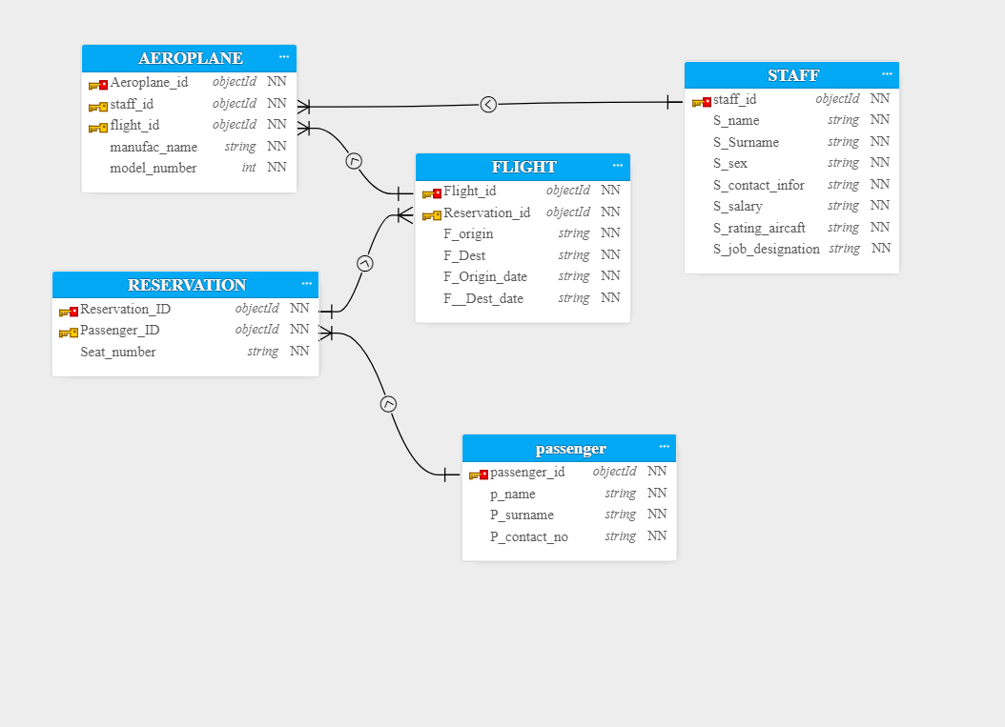

**we also implemented data**

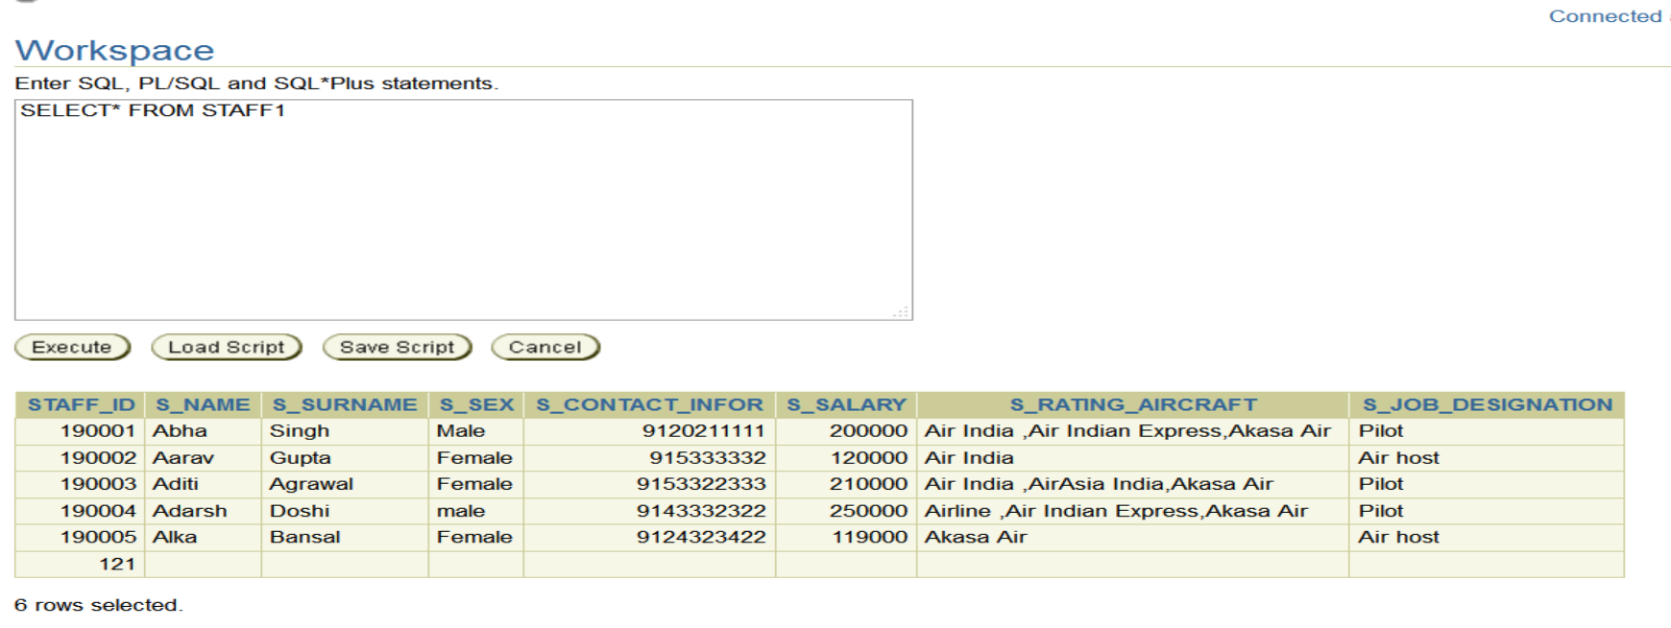

Query of staff data retriveation

Select *

From staff1 ;

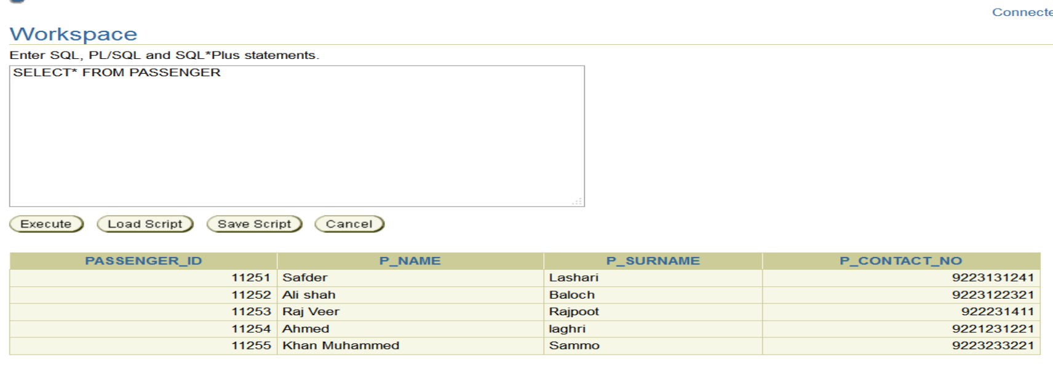

Query of PASSENGER data retriveation

Select *

From PASSENGER;

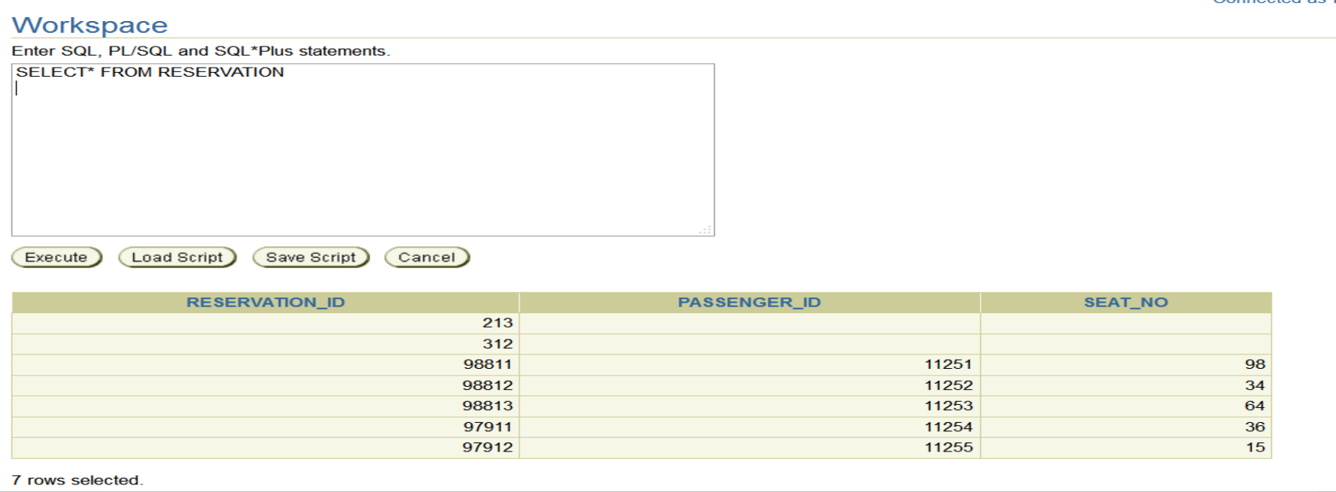

Query of RESERVATION data retriveation

Select *

From RESERVATION;

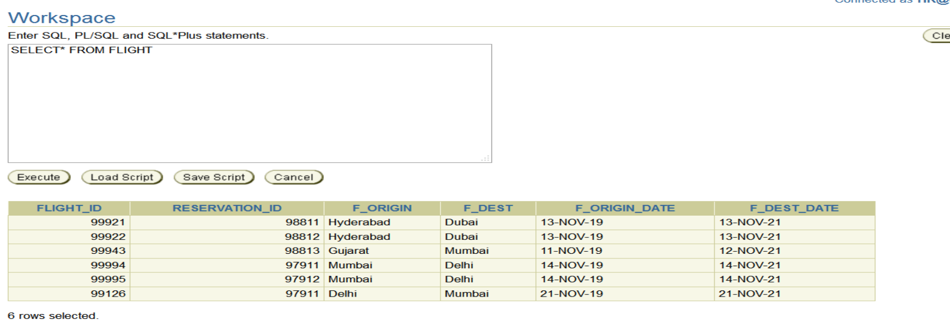

Query of FLIGHT data retriveation

Select *

From FLIGHT;

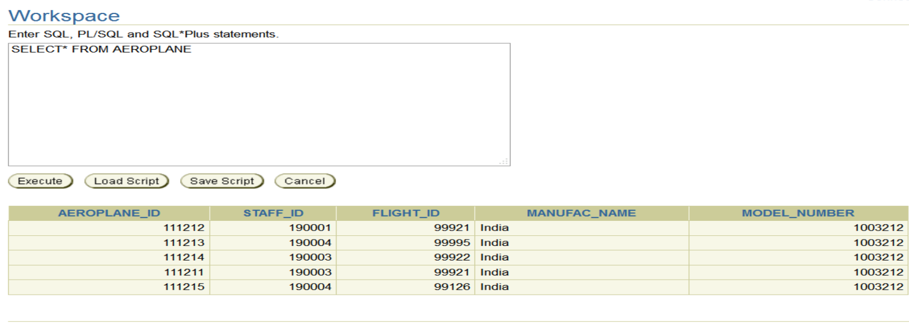

Query of AEROPLANE data retriveation

Select *

From AEROPLANE;

**NOTE**

THESE TABLES AND DATA ARE BASED ON THE NEW ERD,

Therefore

OUR UI IS BASED ON THE NEW ERD

**NOW WE ARE GOING TO UI (BUILD USER INTERFACE)**

**CONNECTION OF FORM BUILDER TO ORACLE 10G SERVER**

Step of connection

1. Run the OC4J Instance or Start OC4J Instance through the command line.
2. Open the application form builder
3. There is an icon of a switch,press it
4. The tab will pop out and ask you the connection thing
   1. User _name
   2. Password
   3. Database
5. Put your username, password, and database on it

Finally, your ORACLE 10G SERVER is connected

1. Run the OC4J Instance or Start OC4J Instance is through command line.

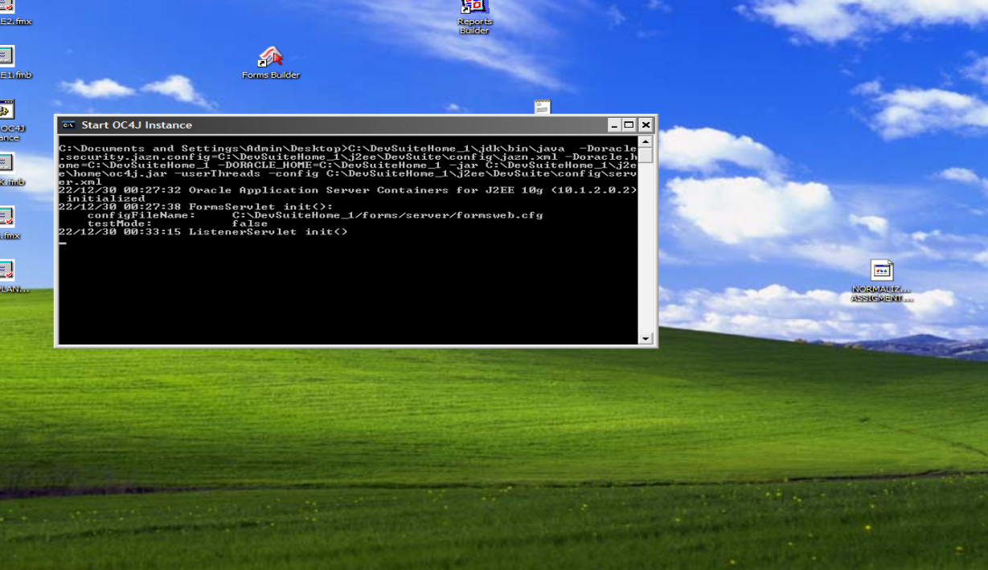

1. There is an icon of swtich ,press it



1. The tab will pop out and asked you connection thing

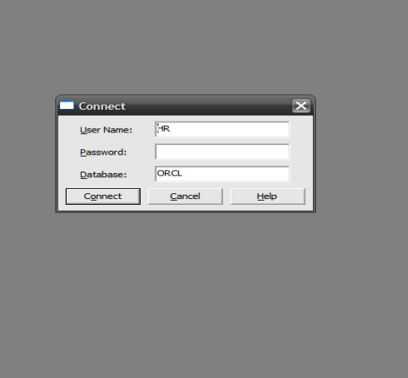

**COMPOUND AND MODULES OF FORM BUILDER** **OBJECT NAVIGATOR**

we have an object navigator it enables our location care for all of the object and modules of the form builder to build an interface

We have many objects and modules, BLOCK but we are going discuss two BLOCK which will make our Interface.

1. **Data block Canvases BLOCK**

These two blocks are very important for making UI (USER INTERFACE)

In data BLOCK we have Compoumnt,OBJECT to make a new UI

* **PROPERTY PALETTE**
* **LAYOUT EDITER**
* **PL/SQL EDITER**
* **DATA BLOCK WIZARD**
* **LAYOUT WIZARD**

1. **PROPERTY PALETTE**

It is used for maintaining the Block object like giving access to the database to the server,name, colouring , and themes button setting, we have lots of button types which you can see in a blow at the picture

**GENERAL SESSION**

* **PUSH BUTTONRADIO BUTTON**

These two buttons are comely used. we are going to use one of them

* **LAYOUT EDITOR**

It gives us a graphical modification facility for creating item like (button, text item) and object in our application.

* **PL/SQL EDITOR**

It is used for the development of triggers,procedures , functions ,packages

**Data Block Wizard**

The Data Block Wizard enables us to create data blocks and modify them. the wizard generates code of enforcing integrity constraints in the database

**Layout Wizard**

 Although the Data Block Wizard allows us to create a new data block easily with its associated data sources, it does not deal with the visual presentation of objects included in the data block.

Layout wizard and data block Wizards gives us privileges button which help to navigates

|  |  |
| --- | --- |
| BUTTON | DESCRIPTION |
| Cancel | It cancels and exit the layout |
| Help | It help us through helping topic window |
| Back | It back the tabs |
| Next | It go to next tabs |
| Apply | We can changes without exiting the wizard available only in reentrant mode |
| Finish | When our layout is complete ready then the button Finish is used |

**Figure of Object navigator**

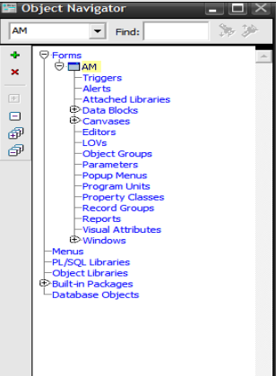

1. **PROPERTY PALETTE**

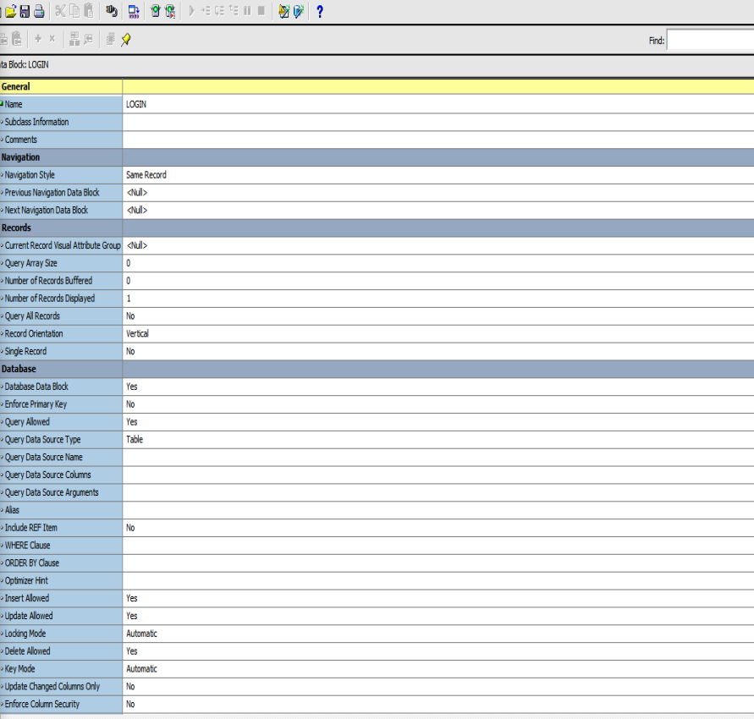

**Data Block Wizard**

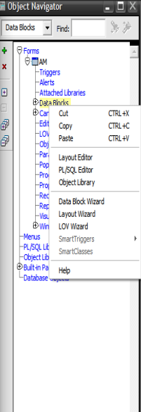

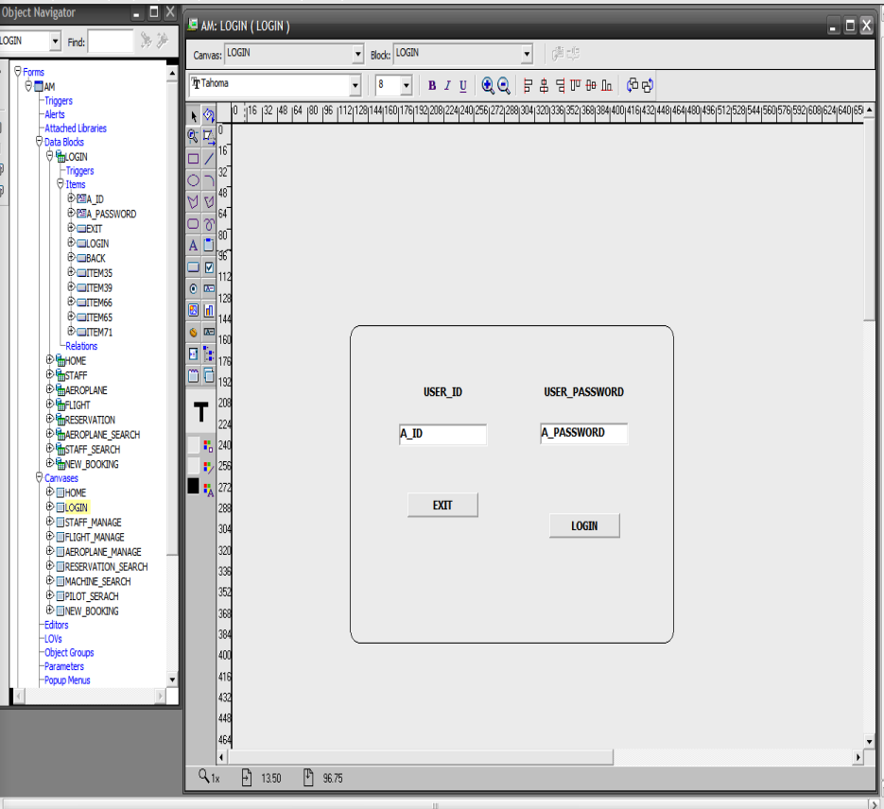

**Layout Wizard**

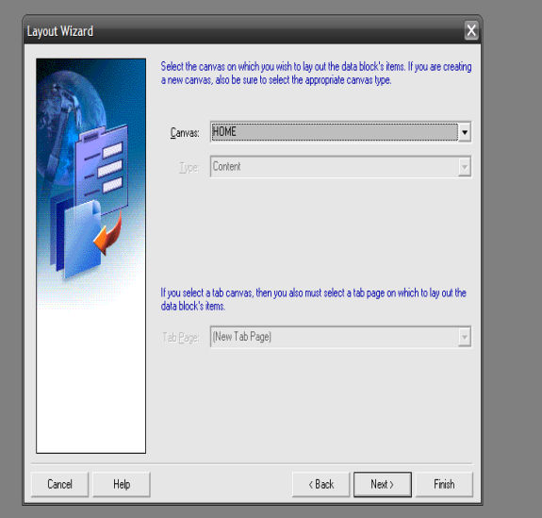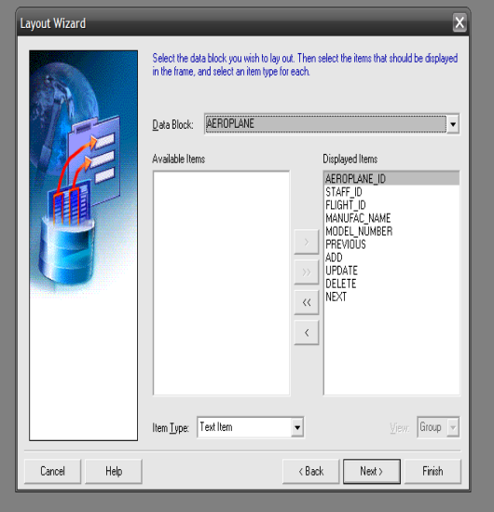

**Now Starting With The Part 2**

After connection we are going to build our new block which is HOME, this block is like a parent that contains all the other blocks, summary, and also access stages of creating HOME BLOCK and HOME CANVAS,

1. Step 1:GO to **OBJECT NAVIGATOR** First of all we are going to create **forms** by tagging on **forms** and then clicking on plus “+” our

Form module will be built change the name like am, or your choices name

1. Step 2: Select the **DATA BLOCK** on the **OBJECT** **NAVIGATOR** then press the **“+”**  then the **NEW** **BLOCK** **BLOCK** tab will pop up which says

* **Create a new data block Use the new data block wizard**
* **Build a new data block manually**

These choices will show on the application

**NOTE**

There is also another way to create a new data block by selecting the data block from **OBJECT** **NAVIGATOR** left click it. there will be an option of >**layout** **editor** .when you click it shows you same option for creating new **DATA BLOCK**

1. Step 3: **DATA BLOCK** is based on logical representation therefore, we select the Build a new data block manually.

1. Step 4: Now rename the **DATA** **BLOCK**.Select new **DATA** **BLOCK** left click >**PROPERTY** **PALETTE** >**GENERAL**> **NAME**>**HOME**

1. Step 5: As we create **DATA** **BLOCK** manually .now we have to create **CANIVSES** manually step are simple

* Select the **CANVASES** in **OBJECT** **NAVIGATOR**
* Press the **“+”**  the canvases will be build

**NOTE**

We have requirements of search, manage, and list, we simply create the button to operate the all data block that we are going to make.the process of making other data block is the same

Therefore

We are going to describe the button .simply we made

1. Three-button for manage

Where we perform add/delete/update/next/previous/back buttons on it

1. Four buttons of browser/Search

Where we perform search/back button

1. Two separate buttons for list view and add new record

Figure of Home page of

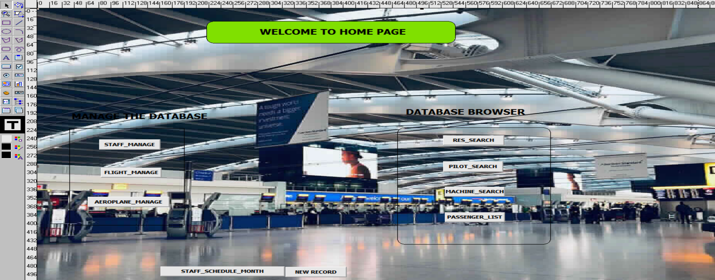

Figure of plus **“+”**

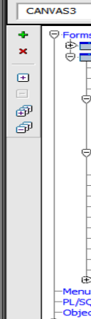

Figure of step 2 , 3

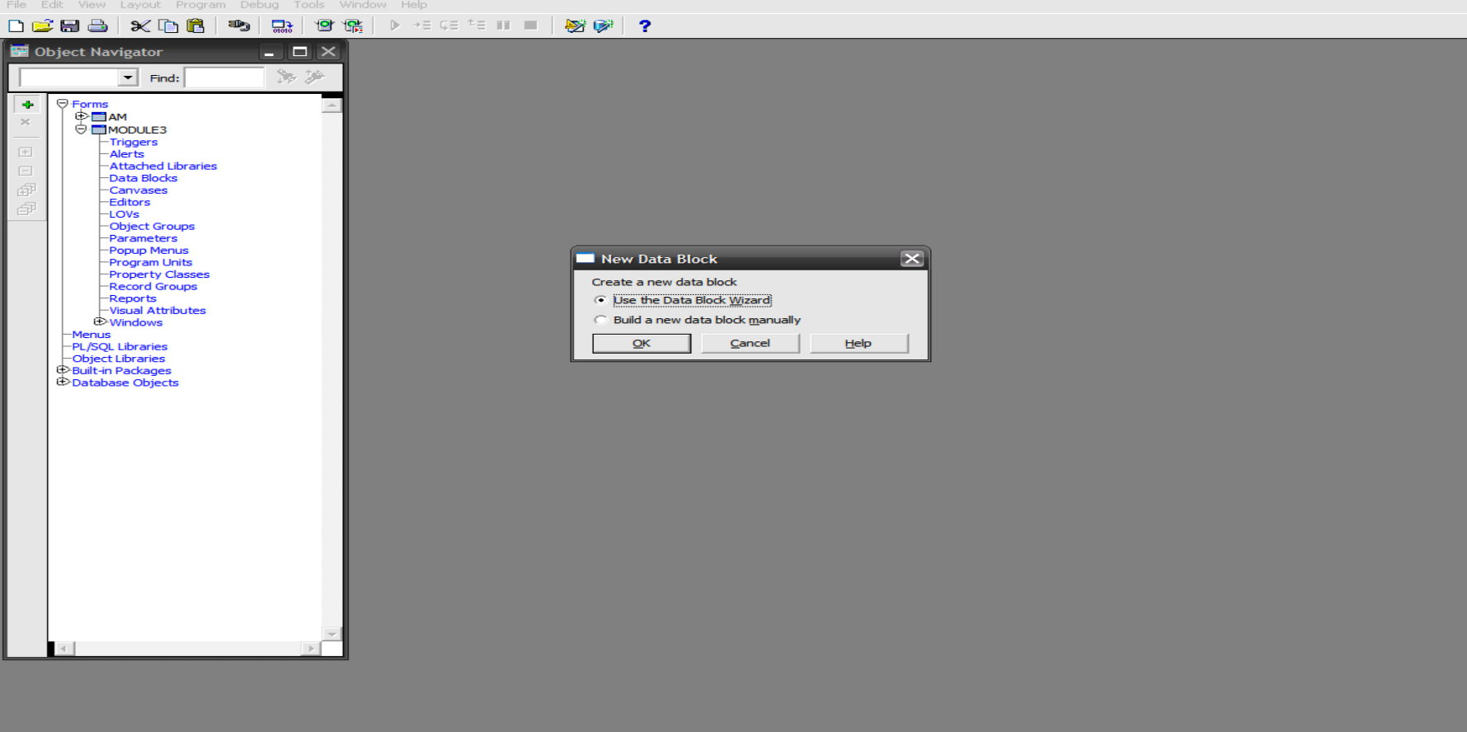

Figure of step 5

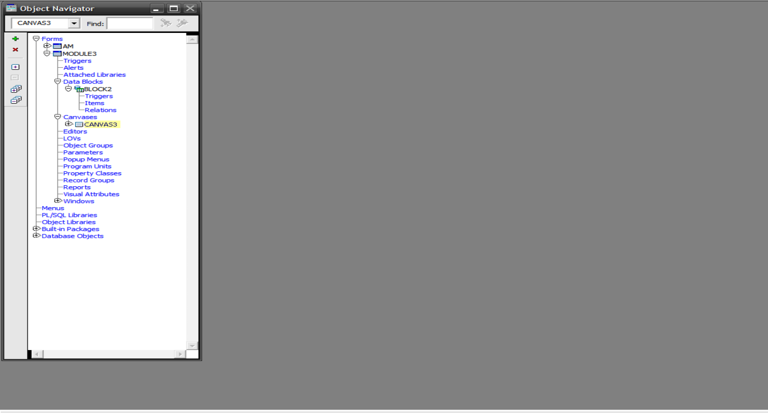

As we create home data block by Build a new data block manually

**NOTE**

There is point when ever we take table from ORACLE 10g server we only use **new data block wizard**

**Figure for guidance**



**There are a few step to the table of data block wizard**

1. Click the **data** **block**
2. Then the welcome box will pop up
3. Next press to next then it will ask you

Select the type of data block you would like to create by clicking on a **radio** **button** blow

**=>Table or view**

**=>Stored procedure**

Click the Table or view option then press the next

1. Then again new tab will show who asks you

Enter a table or view on which to base your data block. Then select the columns that should appear as the item.

Brower the table like the staff table and select all columns like shown in figure

1. Then **master** **details** **relationship** option will be shown press the next button
2. After **the master** **details** **the relationship** new tab will be shown which has two radio button option
3. Create the **data** **block**,then call the layout wizard
4. Just create the block data block
5. We click the 1 option because it will create **data** **blocks** and **canvases**.
6. Then it asks you **canvas** type which we commonly choice **CONTENT** after that press next
7. Then the **layout** **wizard** asks you select the column which we want to show on the data block
8. Then it will ask you layout style frame
9. **From**
10. **Tabular**
11. Select anyone of them .then the **layout** asked you about
12. **Frame** **title**
13. **Record** **displayed**
14. **Distance** **between** **records**
15. Finally, the **data** **block** and **canvas** are build

Step 1 and 2

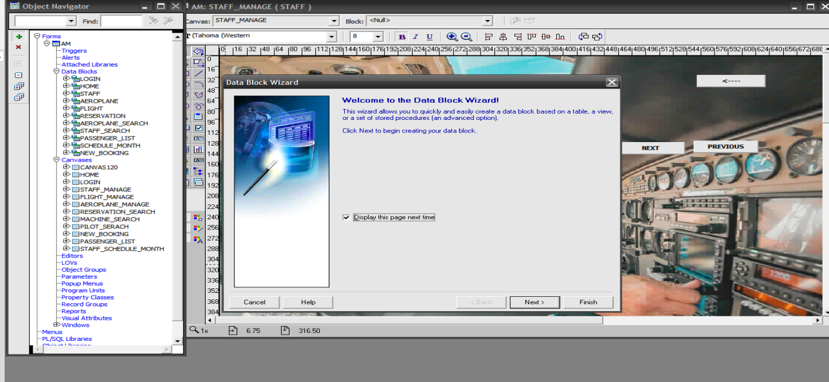

Step 3

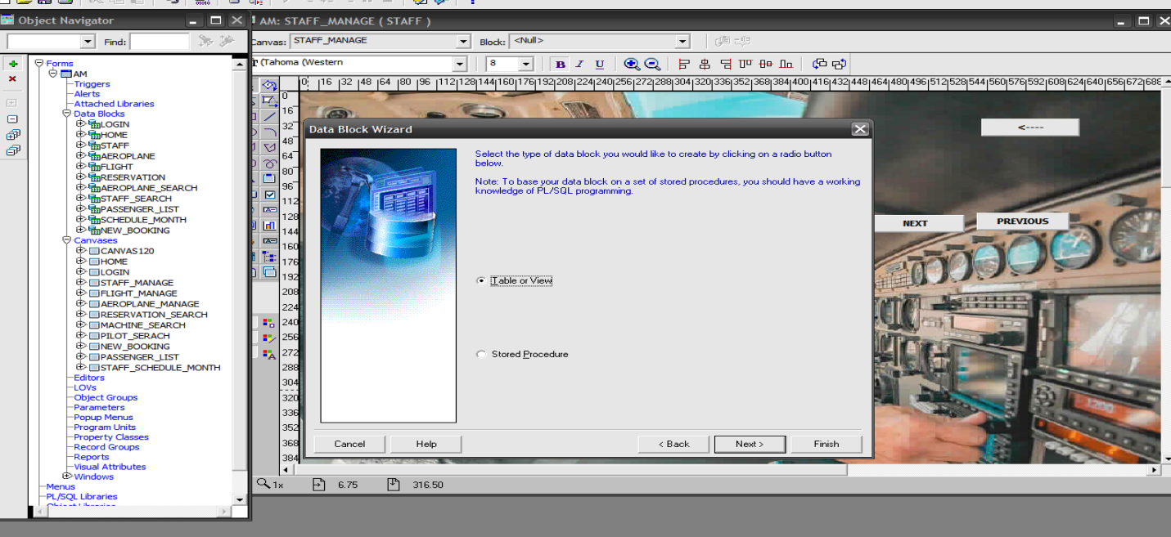

Step 4

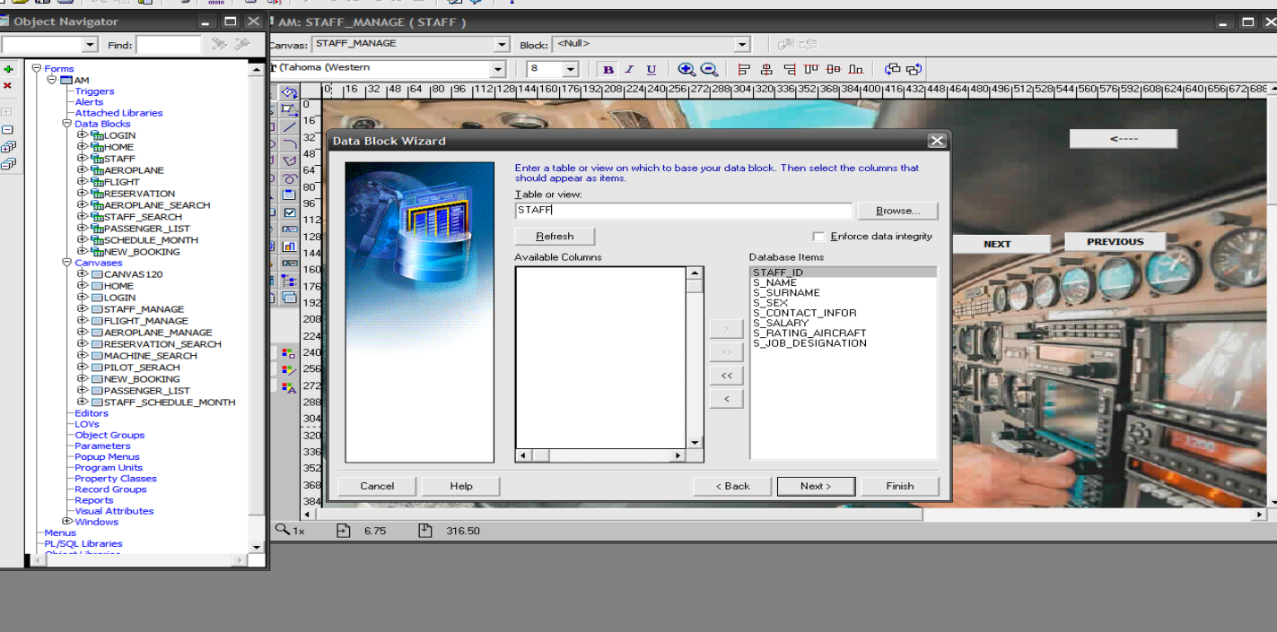

Step 6

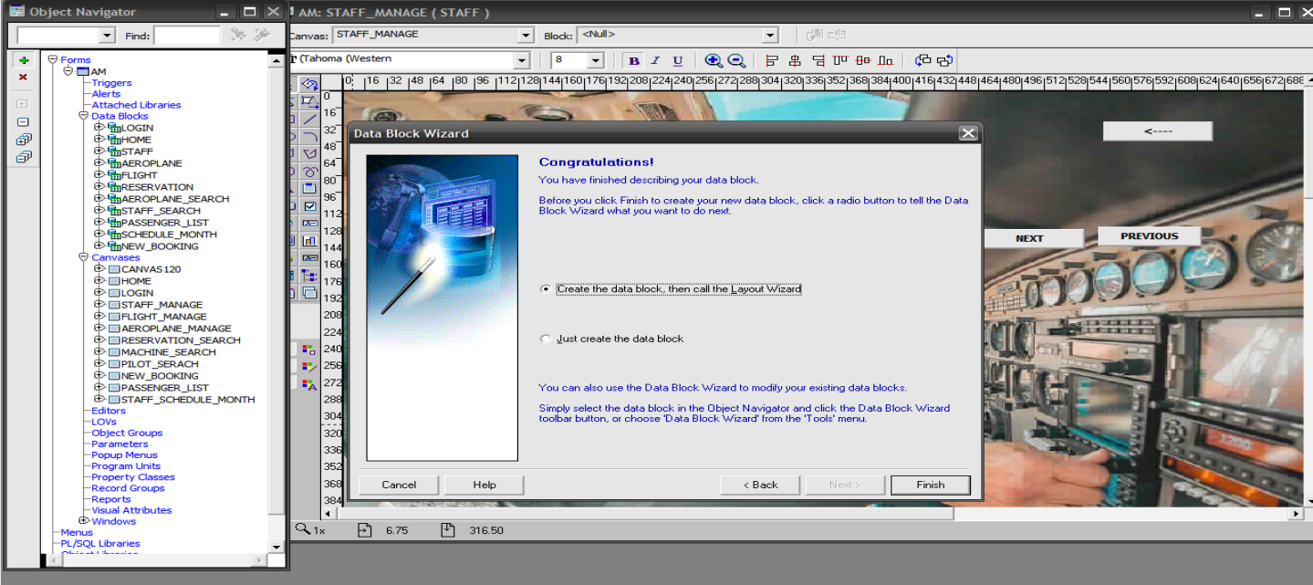

Step 7 & 8

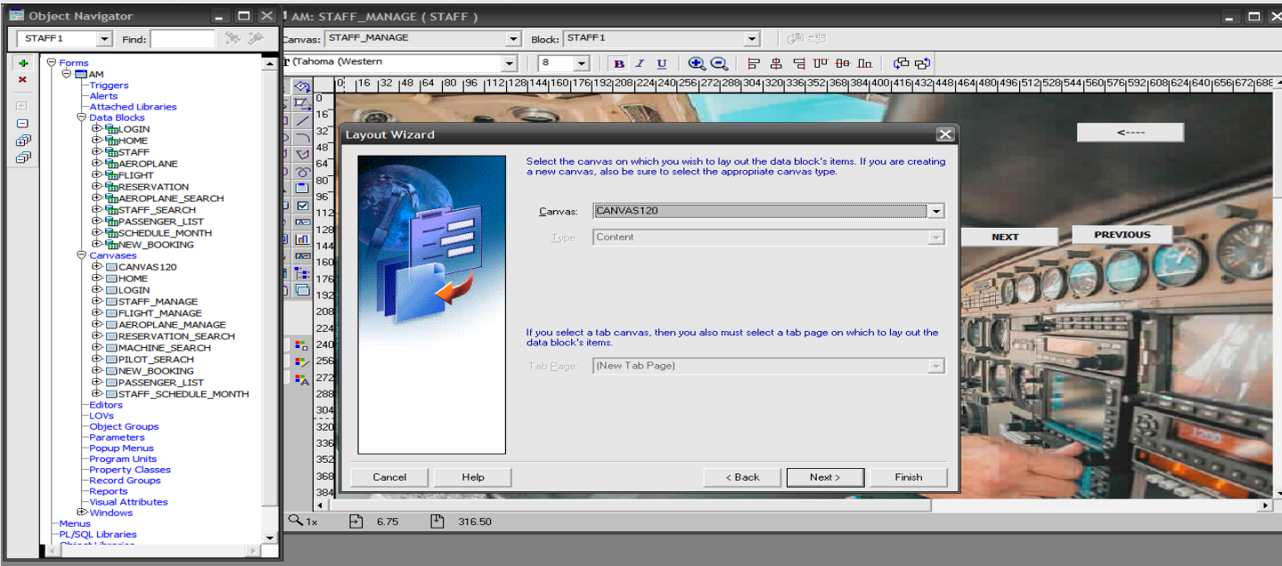

Step 9

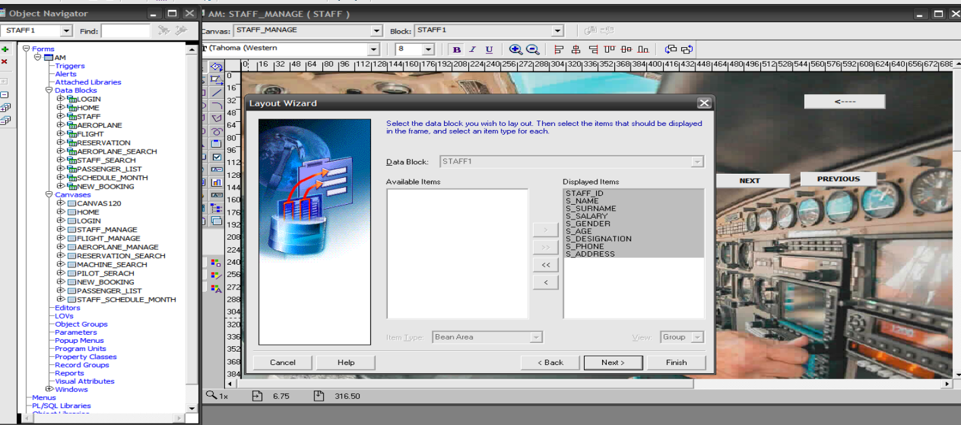

Step 10

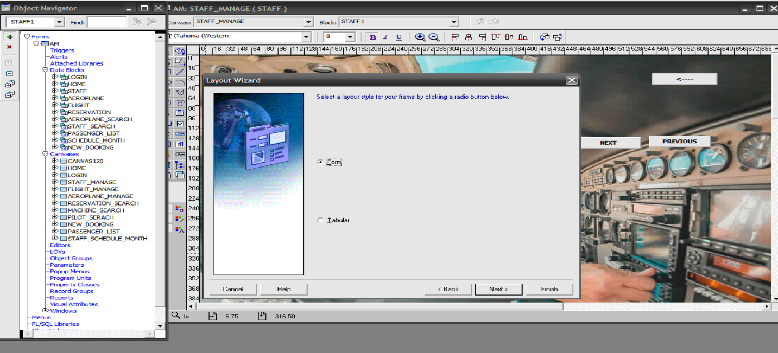

Step 11

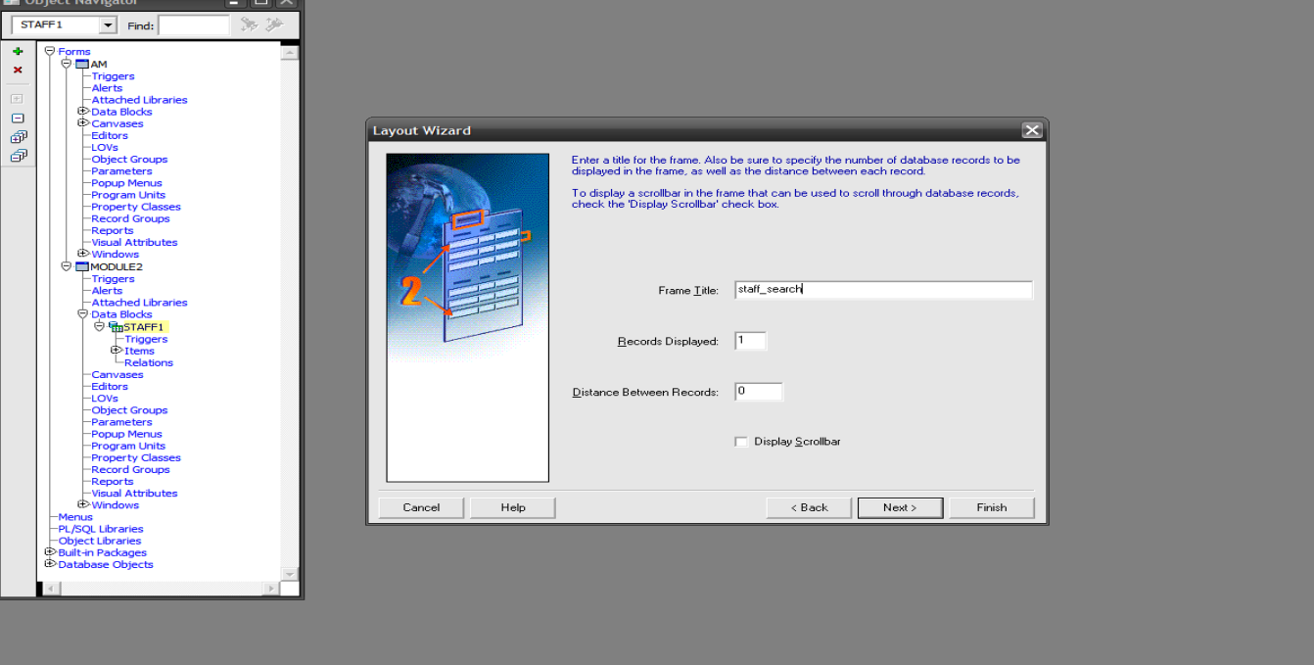

Final display

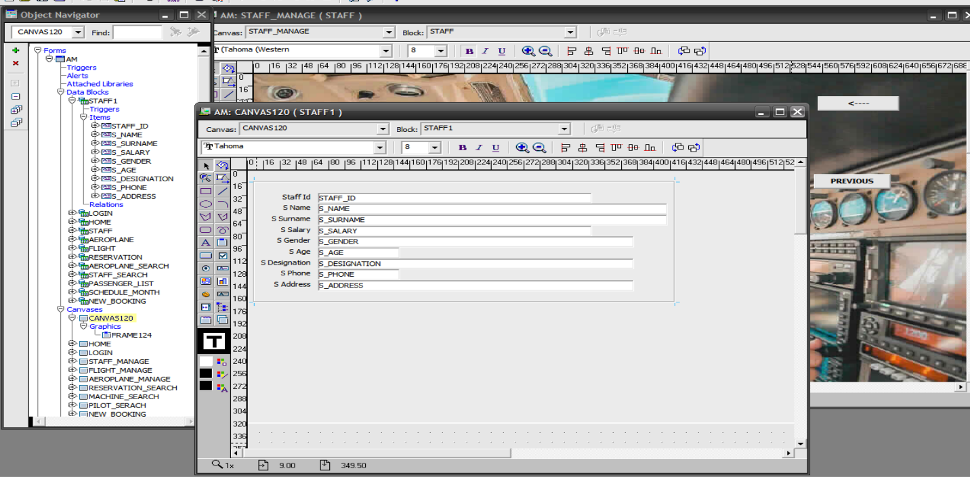

**DATA BLOCK AND CANVASES**

The process is the same as we create a staff **data** **block**, at the end of all blocks we just simply give access to the button of **HOME PAGE BLOCK**, and the backend of a button is provided on the source code file.

BUTTON

Button which we create on the block .

|  |  |
| --- | --- |
| BUTTON | DESCRIPTION |
| NEXT | It show us next data |
| PREVIES | It show us privece data |
| DELETE | It delete the data |
| UPDATE | It will update data , if there is any mistake |
| ADD | It will add or insert new data |
| BACK | It make canvas back |
| OPEN | By press the button we can open the canvas whom we gave the access |
| SEARCH | It will search the record which we provide |

HOME PAGE



Manage staff (add/delete/update and view)

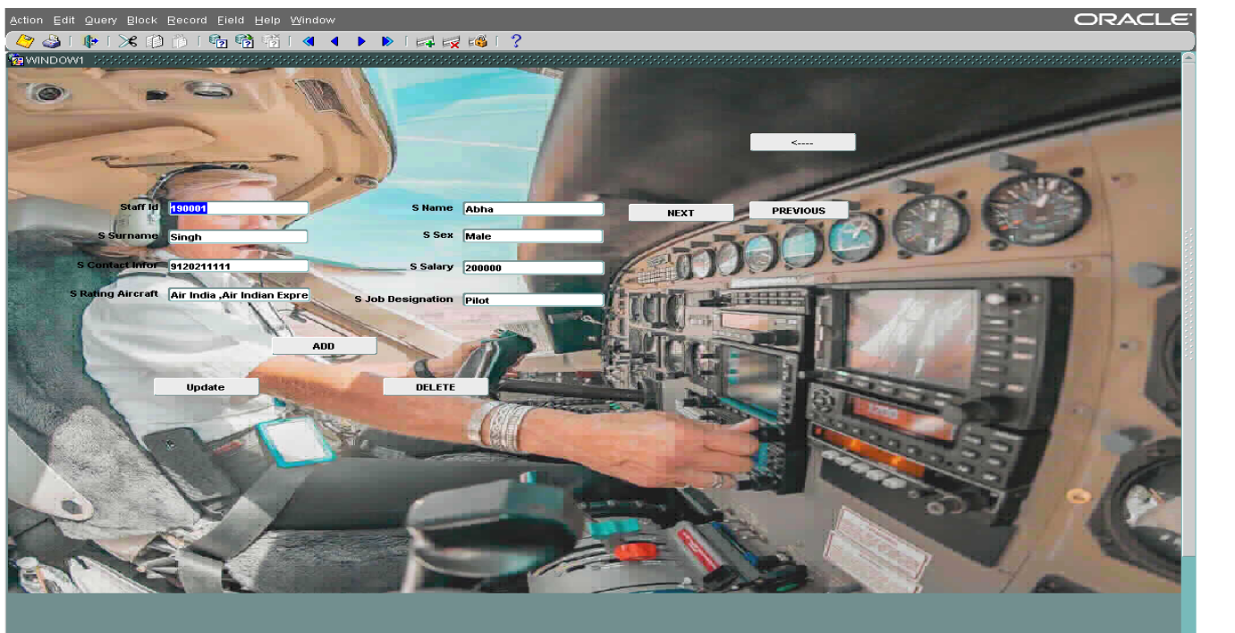

1. Manage flight (add/delete/update and view)

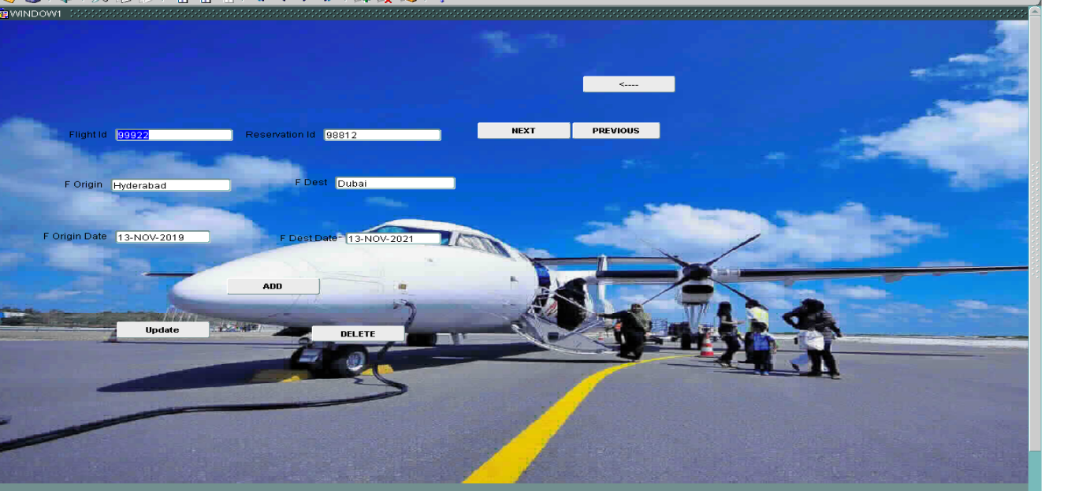

1. Manage machine (add/delete/update and view)

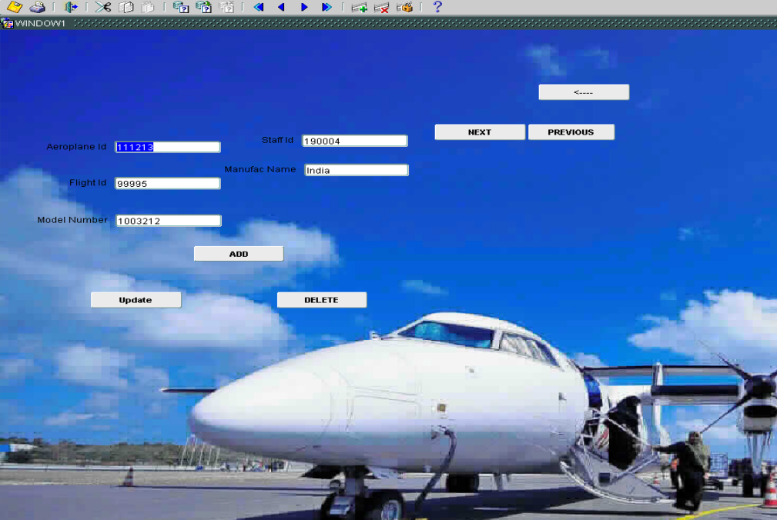

Booking Details search PAGE

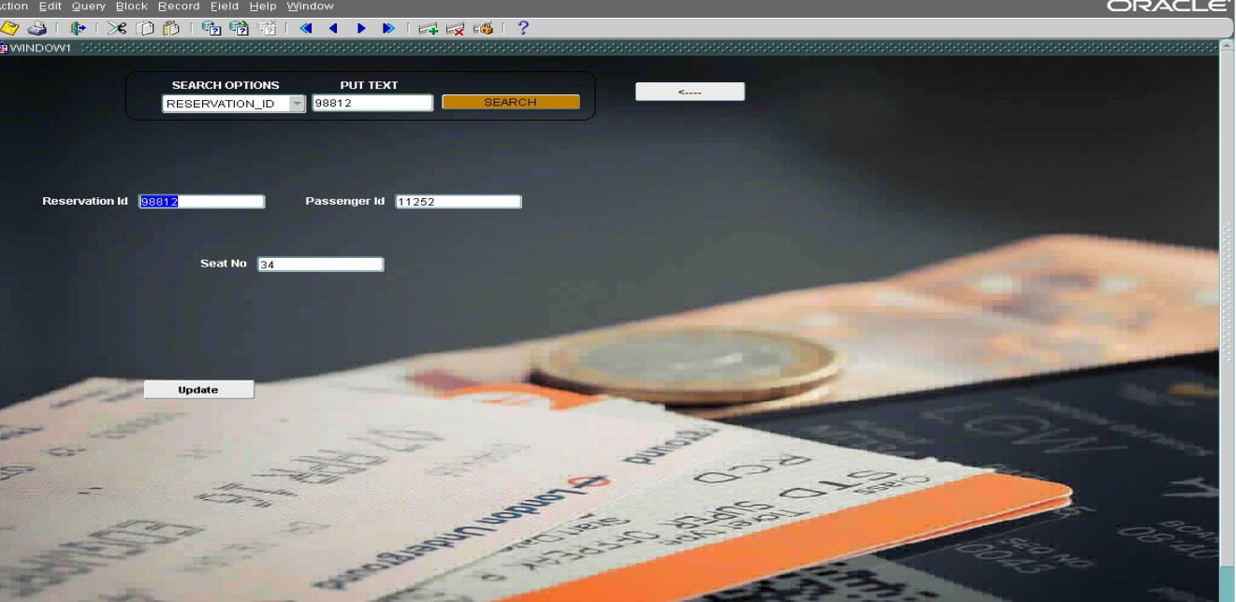

Pilot fly details search

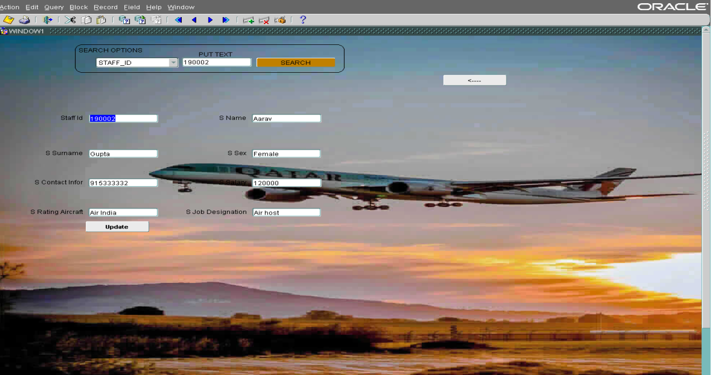

Machine details search PAGE

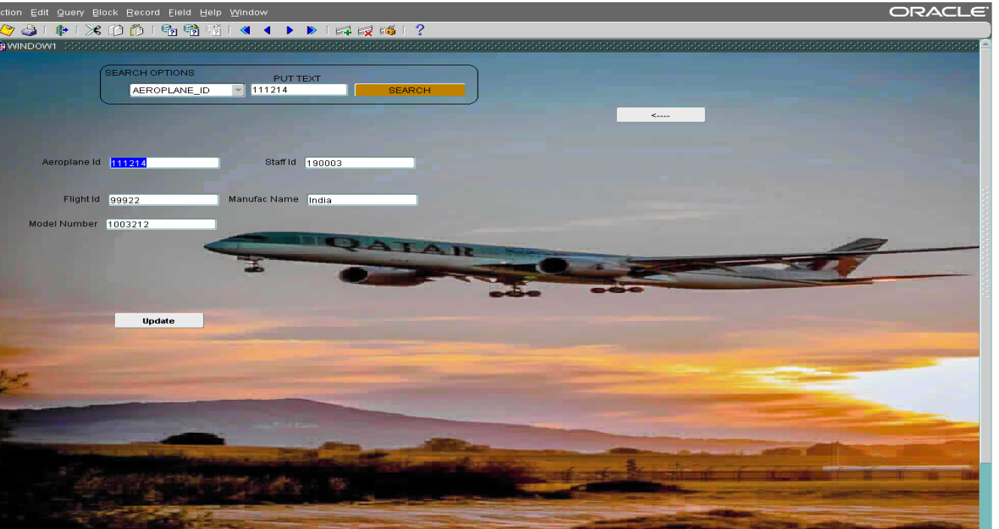

Pilots schedule by month

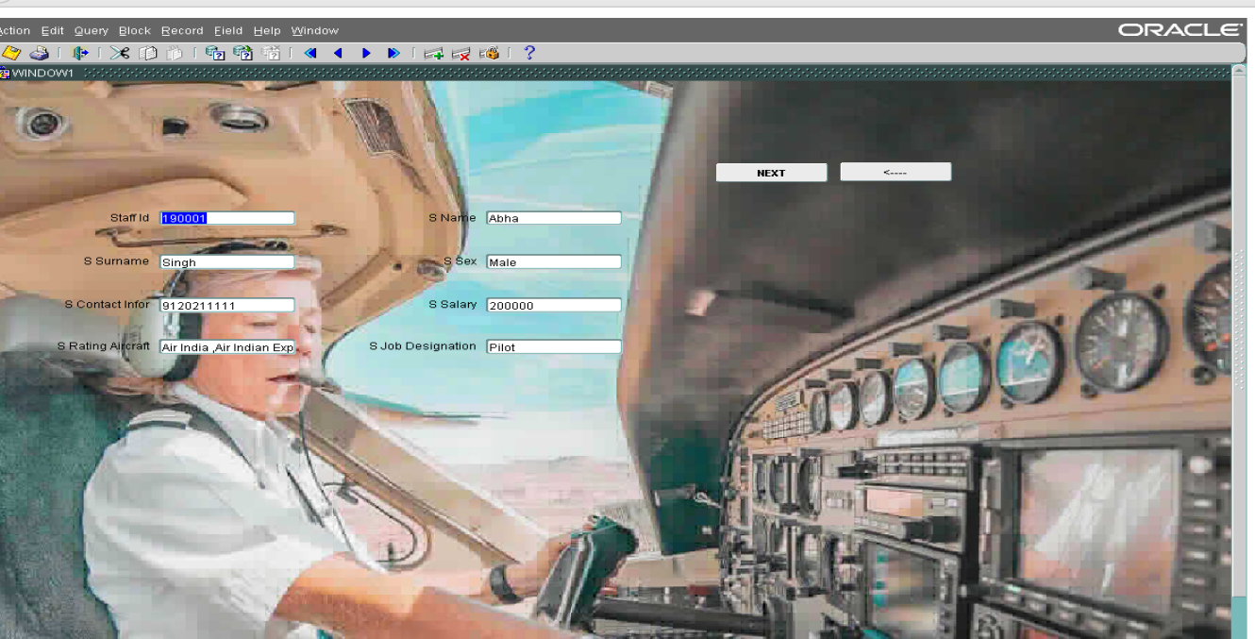

Passengers and their list

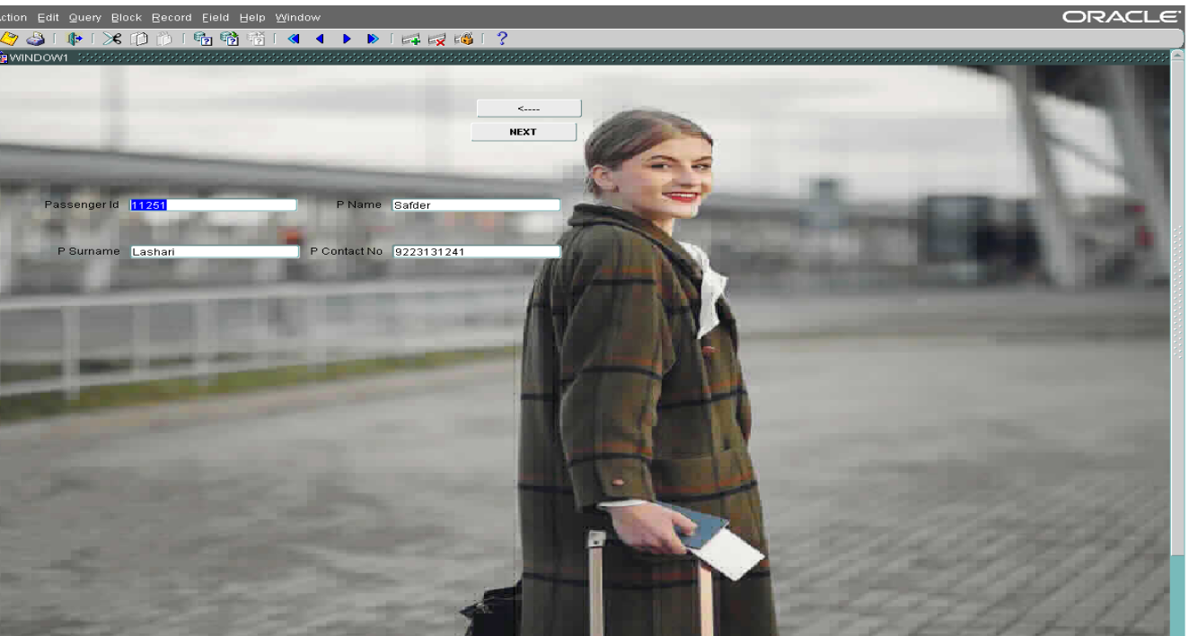

one or more passengers booking

